The movement along X axis (red one, TEST_X)
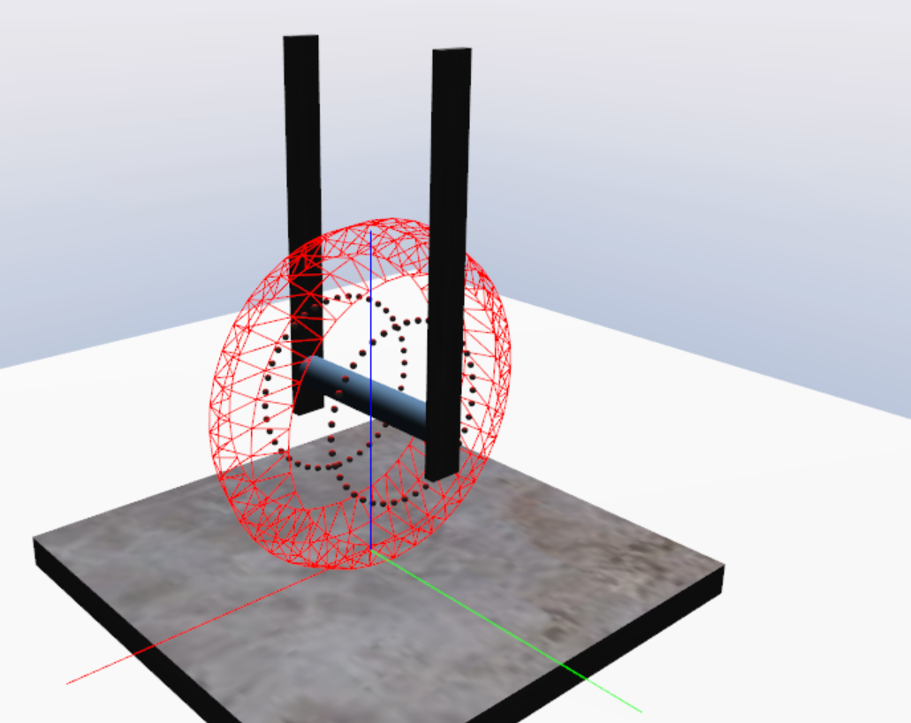

Simplified projection along the red axis, x:
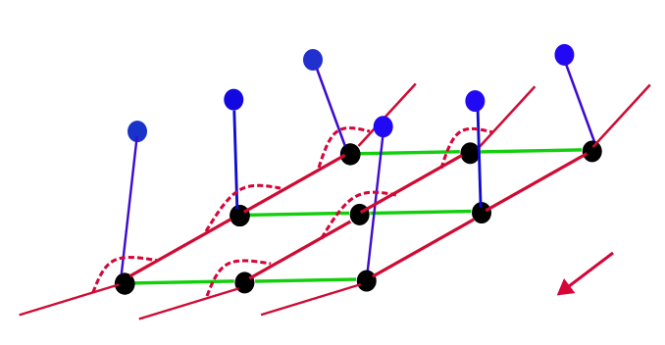

Simplified projection along the green axis, y:


